Open [https://console.developers.google.com](https://console.developers.google.com/) and login to your account

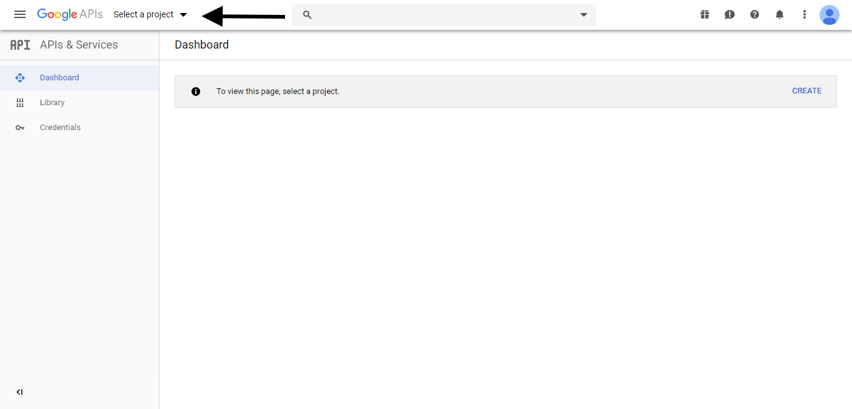

Click Select a Project

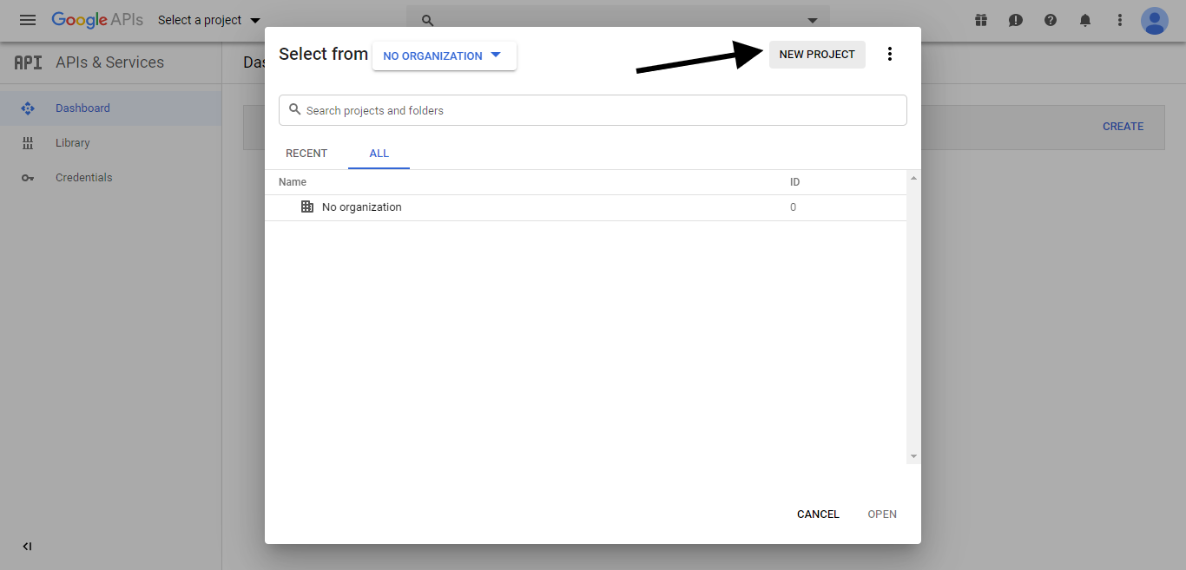

Click New Project

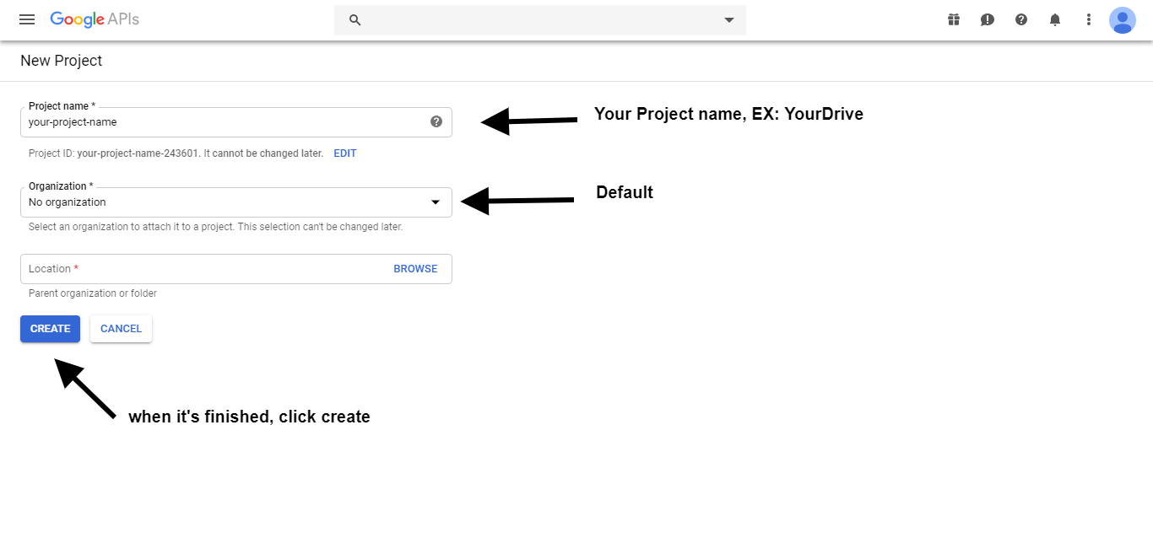

fill in the fields provided

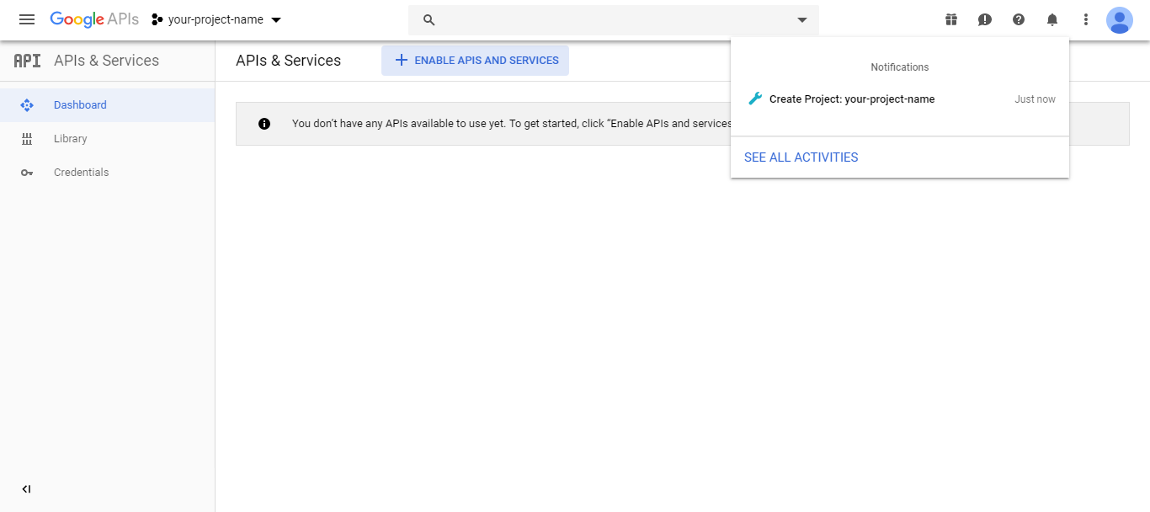

the project was successfully created and then click your project

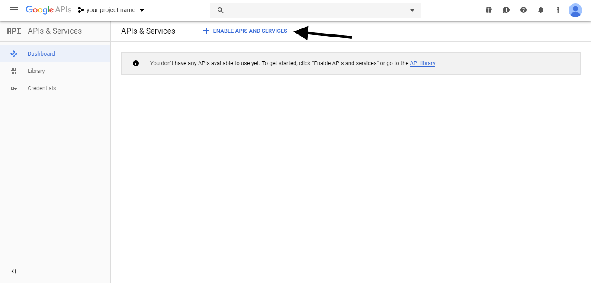

Then, goto Dashboard and click ENABLE APIS AND SERVICES

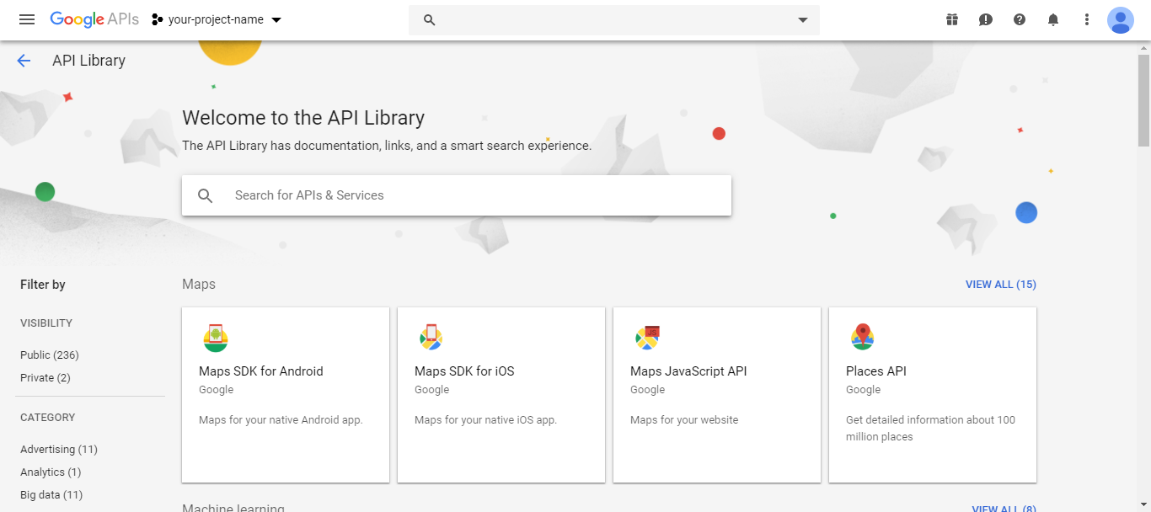

Search “Google Drive API” and “Google Picker API”

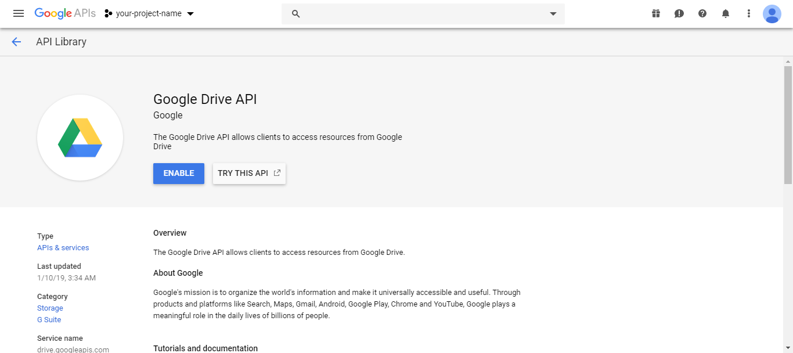

ENABLE it

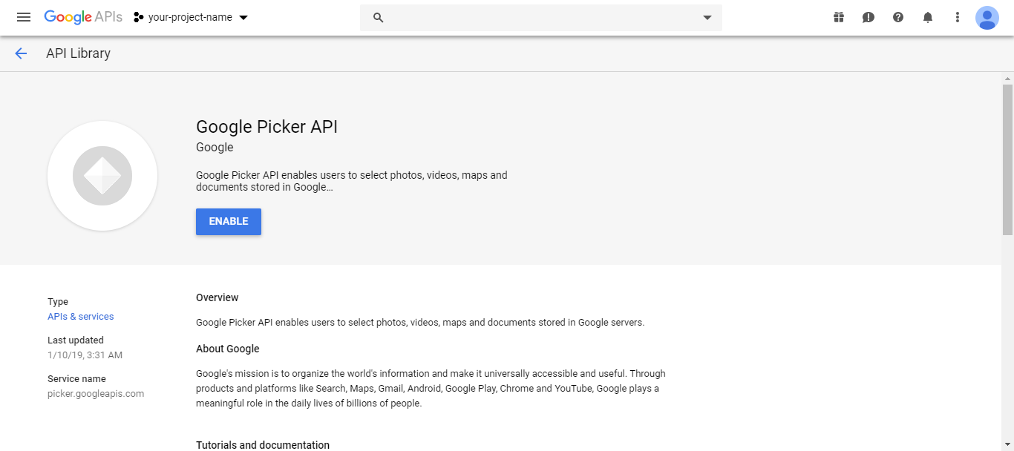

ENABLE it

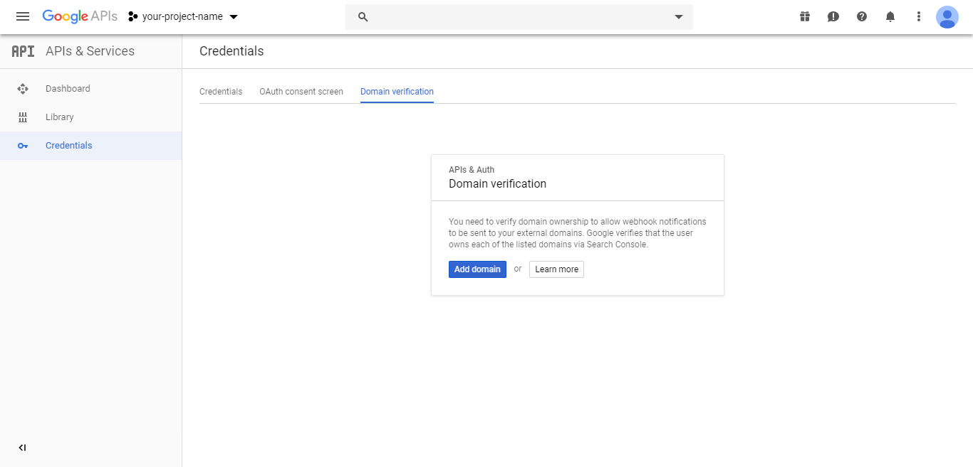Open Credential menu and goto Domain verification tab, there please follow the instructions from google

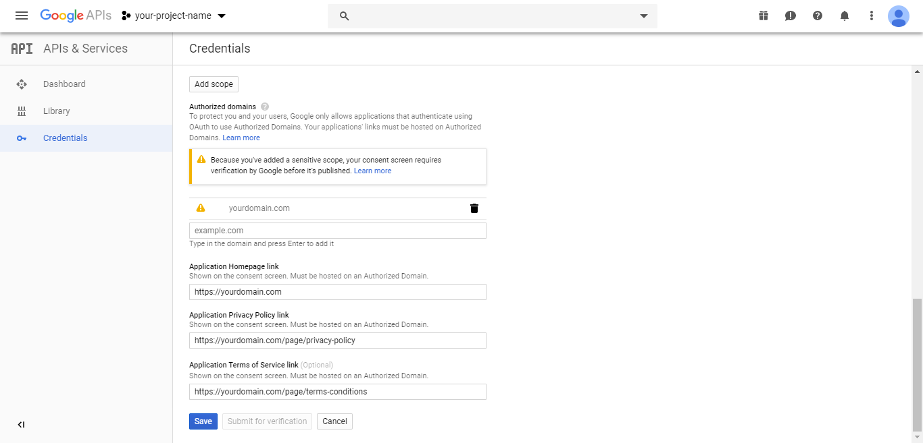

Goto *OAuth consent screen* tab and follow it like this

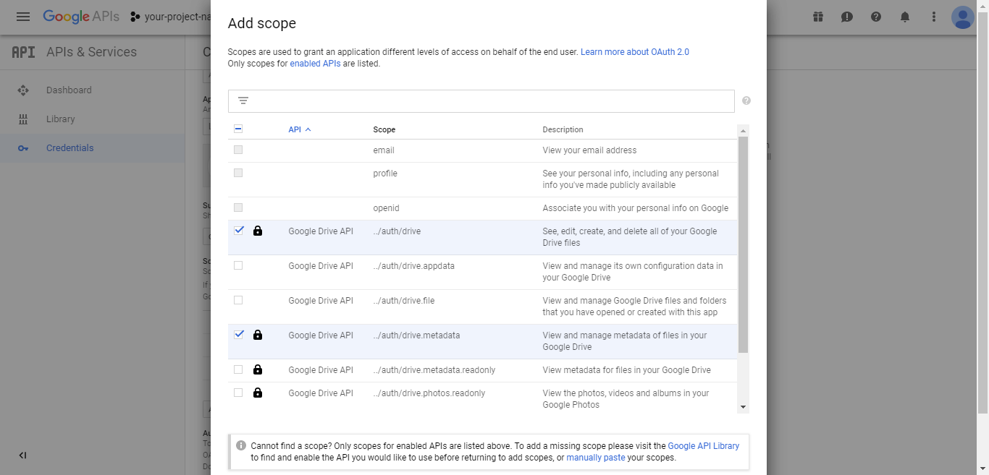

Still in *OAuth consent screen,* click Add scope and thick this and then **Save**

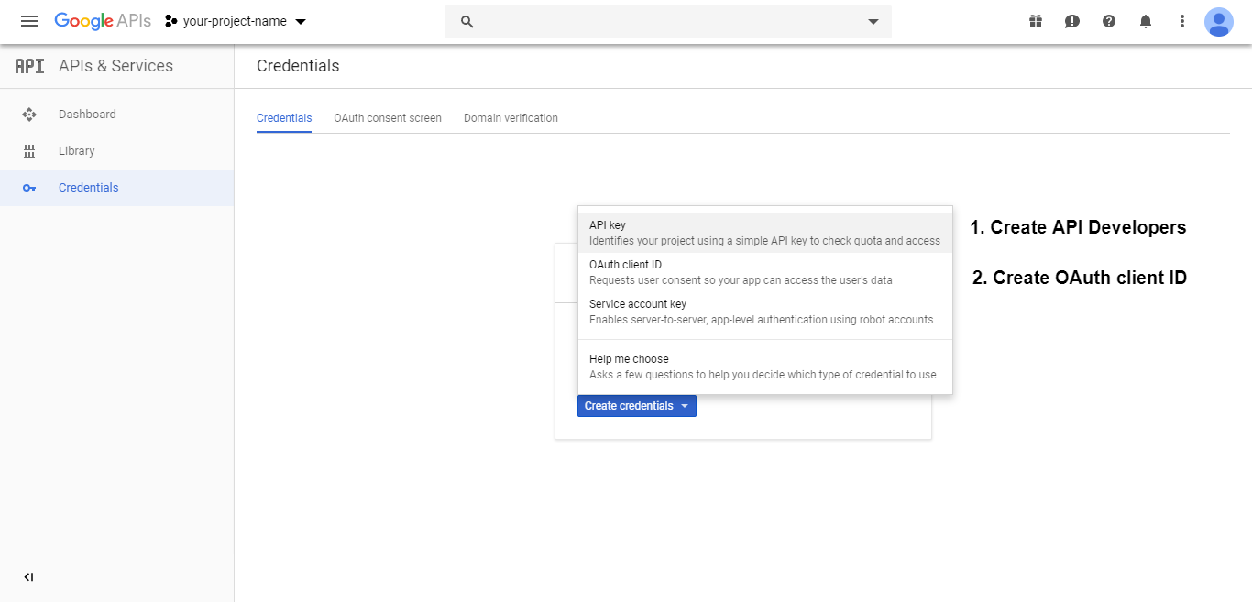

Goto Credentials tab, and first, click **API key** and then click **OAuth client ID**

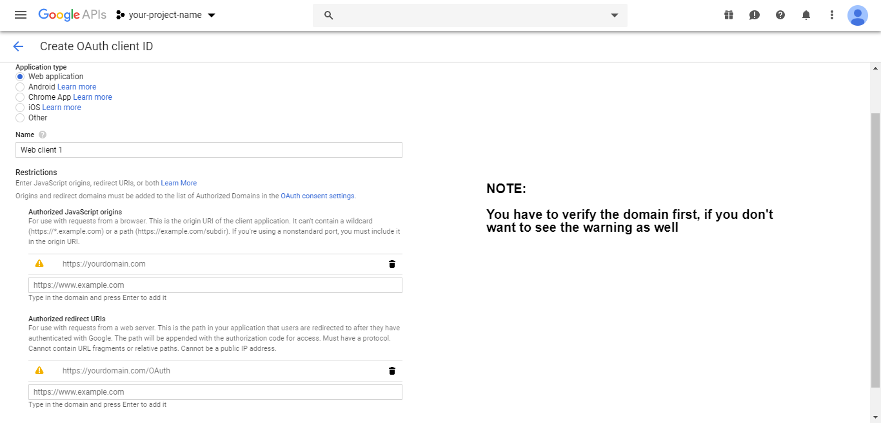

follow it like this, replace it with your domain name. And **Save**

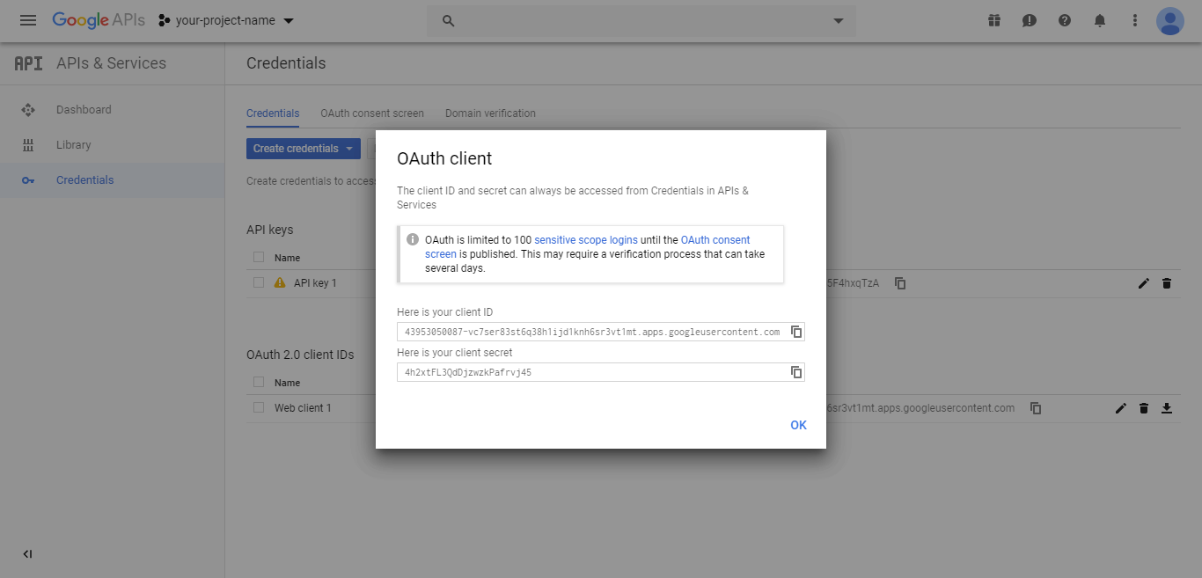

# API Key and Client ID successfully created

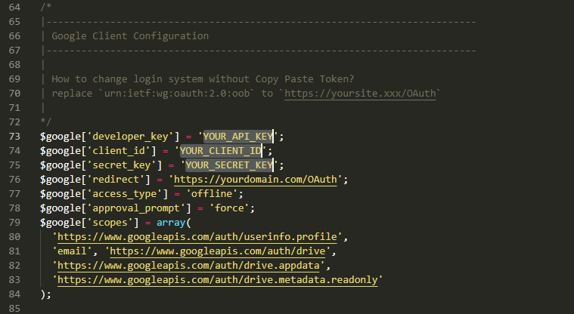

And now please configure it in the script